Chinese Game Research Focused on the Business of Tencent

Austin Easler

Table of Contents
Introduction
Industry Overview
- Key Drivers
- Current Performance
- International Trade
- Globalization
- Market Share Concentration
Competitor Overview
- Excel Spreadsheet of competition with facts
- Small introduction about each company (market share, major games, etc.)
- Key Statistics
Company Overview
- Intro to Tencent
- Workings of Tencent
- Financials
Corporate Structure
- Past Success
- Past Failures
- SWOTT Analysis (Strengths, Weaknesses, Opportunities, Threats, Trends)
- Esports
Competitor Analysis
- More in depth analysis of competitors and any breakthrough in western markets.
- Compare to Vain of Glory (Arguably biggest competitor for Arena of Valor/Honor of Kings
Conclusion

Executive Summary

The ever changing landscape of the gaming industry is often hard to follow. There are many differences between game cultures everywhere you go. From South Korea to London, Shanghai to New York games are all played differently. The market with the largest amount of gamers is undoubtedly China. Chinese gamers are unique as often times the games they play are localized to them from companies in the country. In comparison, while a lot of American gamers play games from America, they also play a plethora of games ranging from Japan to the Czech Republic. In this shared space China remains mostly isolated from outside games and any foreign game that does get to China, is taylor made for the Chinese audience. When studying this topic it is important to take a step back, and look at the overall industry of games in China. Looking at various statistics such as key drivers and current performance, while also factoring in the market share for all major players and the globalization of each. After the viewing of the marketshare, one must look at all competition in the industry. This is a clear indication of how the Chinese Game Industry is performing. Number such as number of employees, number of entities and know which companies are the biggest and why is crucial to understanding the game economy.
We then will narrow the focus on the biggest publisher in China, as well as the rest of the world, Tencent. we will do a dive into how they run business, what there operations are like, how they are performing financially, and most importantly how there mentality affects their products. Because Tencent doesn’t just make games, all aspects of the company will be discussed. Tencent’s corporate structure and its position in China as a tech giant is a vital issue that will be covered, as they are one of the largest corporations in China, and the world. When we talk about the company, it is essential to note its past accomplishes and its past failures. Then we will look at a SWOTT analysis which stands for strengths, weaknesses, opportunities, threats, and trends. These topics will really show the current status of Tencent and how they can adapt to the future, as well as what to watch out for. In topic with the future, eSports is a huge key principal to take into account when looking toward the future. This possible revenue stream is almost entirely unexplored by publishers, and most commitment usually stems from the sponsorship of the grassroot scene. Finally we look a list of competitors for the game Honor of Kings/Arena of Valor, and see how it stacks up against the competition, mainly being Vain Glory. We can see the revenue increase through China and see how Honor of Kings affects it. Finally we will discuss the successful expansion of Honor of Kings to the western cultures with the rename of the game being called Arena of Valor.

Industry Overview

Key External Drivers
Key drivers are an important indicator in any report to know what drives a specific market. In this case, these are the key drivers to the game market in China.
Personal Discretionary Income
Demand for the online gaming in China, as in the rest of the world, is dependent on the level of disposable income. According to the government report presented in the 18th National Congress of the Communist Party of China, the Chinese government plans to double household incomes by 2020 starting from 2006. These increases will raise the personal final consumption expenditure, which will benefit the industry.
Internet Connections
Online game play is reliant on internet connections. Internet speed affects the playing experience, and internet coverage levels affect the number of potential users. Phone networks such as 4G LTE has made mobile online games more popular, which support the development of the industry. Mobile online games have become a new growth point of this industry.
Internet services are another cost structure item for online game producers. The cost of gaming, (i.e. servers for players and the company) heavily depends on the price of internet access services. Game play also requires an internet connection to play online. Therefore, a fall in the price of internet services positively affects the industry.
Systems and Technology - by Industry Sector
As a high-tech industry, technology drives the development of the Online Game industry in China. New technology can support the launch of new products and services and reveal new ways to increase revenue both long term and short term. The rapid pace of technological change may lead to changes in the structure of the industry in the future.
Age Group (10-50)
The primary users of online games are people aged between 10 and 50 (Newzoo, 2017), but the majority of gamers (564.8 Million in China) falls between the ages of 15 and 34. Restricted by China's birth policies, which was formally phased out January 1st, 2015 , the growth rate of this segment of the population is falling, which may have a negative effect on demand for the Online Game industry in China.
Current Performance
The 564 million gamers in China generated $27.5 billion of the industry's $108.9 billion global market value (as forecasted by Newzoo), just ahead of the U.S.’s $25.1 billion. A notable contributor to the growth has been Apple's mobile app store in China. In 2016, China accounted for 31 percent of the total $18 billion generated by games on iOS, compared with just 3 percent of the $2.4 billion total in 2012. (Bloomberg Technology)
As shown in the below chart, The Online Game industry in China experienced rapid growth, with revenue increasing at an average annualized rate of 28.3% to $27.7 billion. Such rapid growth was driven by the development of internet services in China and support from the government.
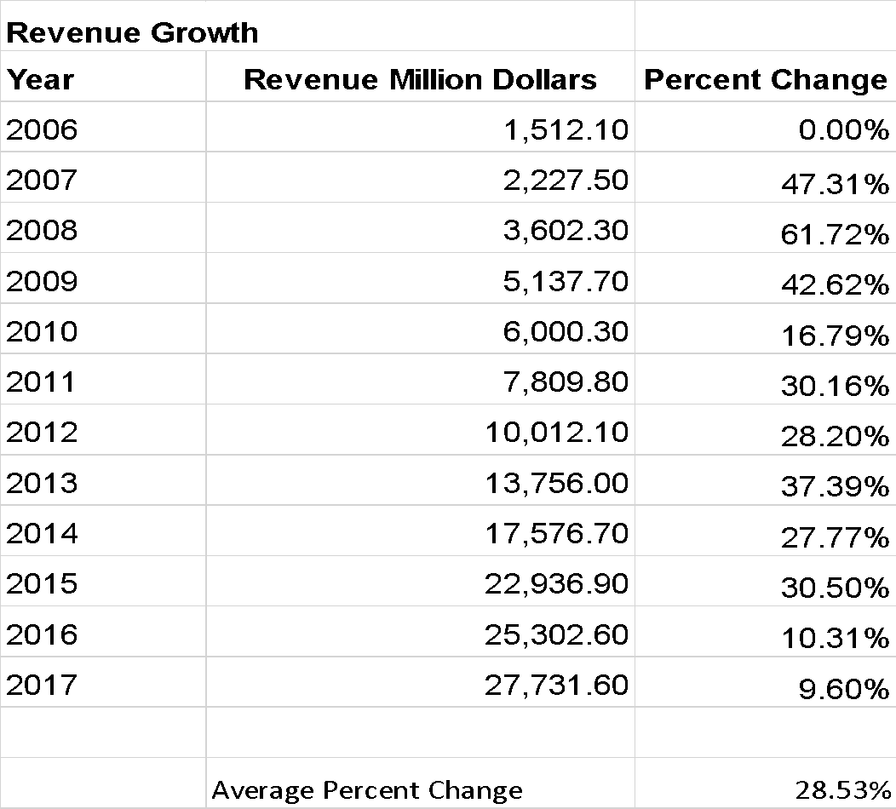
Revenue Growth in USD
The number of online game users is 416.9 million, which means over a quarter of Chinese residents play online games. According to the China Internet Network Information Center (CNNIC), the number of internet users was 710.0 million in mid-2016. Online game players account for 56.9% of internet users.
Revenue streams and profitability
Online game companies have developed many ways of generating revenue. The most common method is prepaid game-time cards. Users can play games until the balance on their time cards runs out. Another revenue stream is virtual items within free games also known as microtransactions. Other methods of generating revenue include monthly flat rates and advertising.
Compared to other internet services such as online video and electronic commerce, online games are more profitable. In 2017, industry profitability is estimated at a whopping 40.5% of revenue. Most of the publicly listed online game companies make over 50.0% profit. In terms of price/ earnings (PE) ratio, three of the top ten most profitable Chinese companies listed on the NASDAQ are online game companies.
Enterprises and wages
There are about 6,521 online gaming companies in China. The number of enterprises has been increasing strongly at a rate of 18.0% annually over the past five years. The rapid development of the mobile online game segment has attracted a number of new enterprises.

International Trade

Exports
Chinese online games have price advantages. Online game agencies are keen on introducing Chinese games into the markets in their countries, since the low prices make them lower risk. However as stated in the IBIS World industry report, “most Chinese online games are about Chinese Wu xia and Kong fu culture’s which limits their global spread.” (IBIS World) Exploration of traditional Chinese cultures, being Kong Fu and Wu Xia, makes these topics the primary selling point for the overseas markets Furthermore, compared to mainstream U.S. and South Korean online games, domestic games are less technologically advanced. Because of this Exports have been growing faster than total revenue, $8.5 billion in 2017
Competing imports
The Chinese online game market was dominated by foreign games in the early years of the industry's development, domestic games only took the leading share in 2006 (Newzoo). The mainstream games in the market are from South Korea and the United States, with the most profitable games coming from South Korea. Games from Japan are expected to hold higher market shares in the next five years.
Industry Globalization

The Online Game industry in China has a moderate level of globalization and is only expected to grow in the coming years. Domestic game companies have expanded their business to overseas markets in the past five years. The most common ways to export domestic games is to sell the operating licenses to foreign agencies. Some Chinese game companies also take charge of the operation process.
Chinese online games have been accepted by players in many regions in the world. As stated by IBIS World “[In addition,] the government encourages game producers to export their products.” (IBIS World) With encouraged exports by the Chinese Government, we can safely assume that the global influence of Chinese game firms will only increase in the future. A possible route for distribution channels is that by 2020 phones are expected to have 40% of the market share and make up 64.9 Billion USD (Newzoo)

Competitor Overview
Market Share Concentration
In 2017, the top four players in the Online Game industry in China make 61.5% of total industry revenue (according to Newzoo), which indicates a medium level of concentration. The Market is heavily skewed toward a few big publishers, such as Tencent and NetEase. The other companies listed within are still often making games, but they don't have the same download rate as the big players. This pie chart only contains some of the major companies that are (or were at one point) publicly traded. While there are other big players that exist, any private company that on this list is there because they have a significant amount of popularity in more than one game.
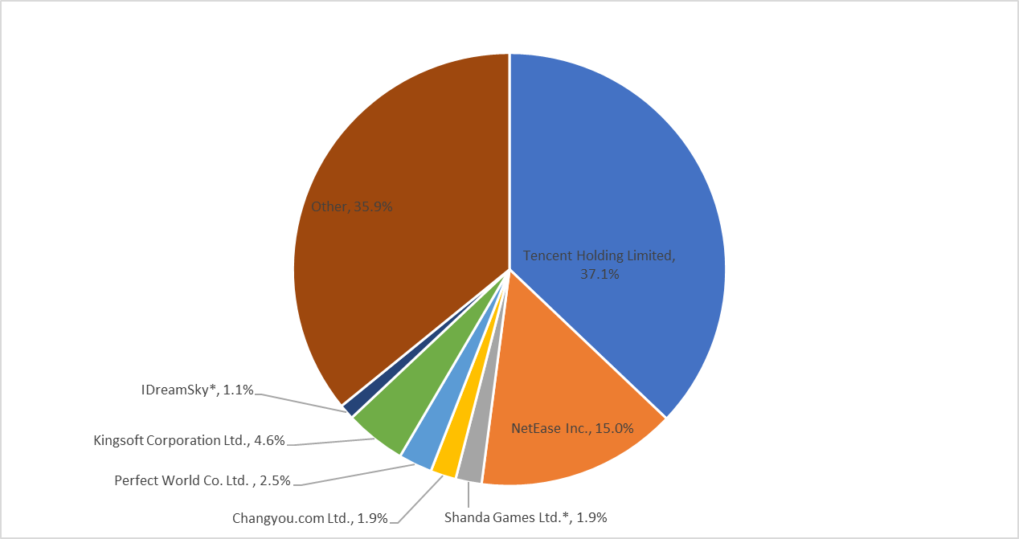

Market Share Concentration of the Largest Publishers in China
Although Other is a dominant force, its origin is often times a game not made by a full publisher, but rather an indie developer much like Angry Birds by Rovio in America. An interesting trend amongst Chinese Publishing Firms that a majority of the mid-sized publishers were once publicly traded companies on either the NASDAQ or NYSE but have since been delisted. Most of the companies have been delisted around 2014-2015. The reason for this being the Chinese Government. China’s stock market had soared during 2015 thanks to a actions made by the Chinese government, and the government wants to build its own capital investments. In a sense, the Chinese Government wants the Chinese based companies to delist from American markets and relist in Chinese Markets, either being the HGEX (Hong Kong Exchange) and SSE (Shanghai Stock Exchange). The below spreadsheet has a list of the major Chinese Publishers, along with if they are traded, their revenue, and their market share. In the event that the company used to be public and had gone private the Revenue was estimated given the last known financials and forecasting forward, finding the best fit line for the residuals
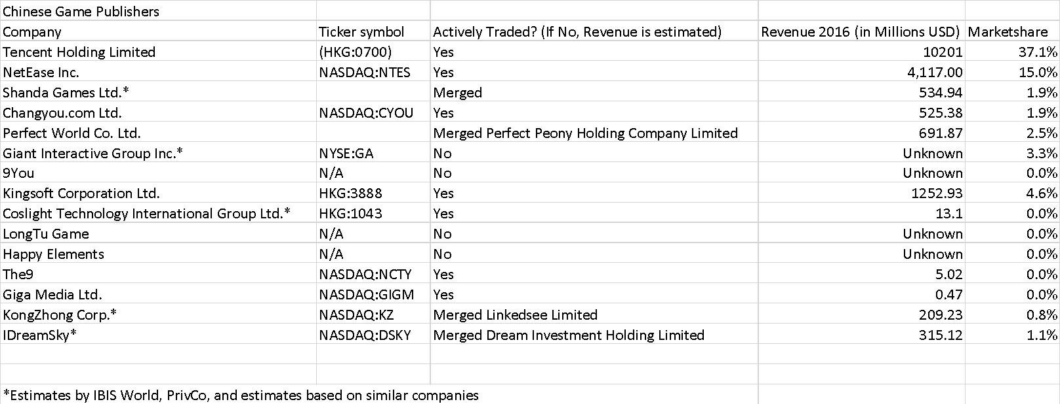
Excel data for Market share

Competitor Description
Tencent Holdings Limited
Brand Names: QQ Game Center, Cross Fire, Dungeon & Fighter, Honor of Kings
Tencent is one of the biggest investment corporations, one of the largest Internet companies, as well as the largest, best-performing and most valuable gaming company in the world. Its many services include social network, web portals, e-commerce, mobile games, smartphones, and multiplayer online games, which are all among the world's biggest and most successful in their respective categories.

Netease.com, Inc.
Brand Names: Westward Journey Online, Fantasy Westward Journey, World of Warcraft
Founded in 1997, the company was a key pioneer in the development of Internet services for China. Today, NetEase develops and operates some of China's online PC and mobile games, advertising services, e-mail services and e-commerce platforms. NetEase has produced some of China's most played online PC-client games.

Shanda Games Ltd.
Brand Names: AION, MapleStory, Ragnorok Online, Dungeons & Dragons Online
a Chinese operator of online games and book publisher, based in Shanghai. In 2005 they claimed to have 460 million registered accounts, and of those accounts, an average of 1.2 million players at any given time. In 2015, Shanda changed its operation strategy and strengthened mobile game R&D. The company was also delisted from the Nasdaq at this time.

Changyou.com Ltd.
Brand Names: Echo of Soul, Legend of Sword and Fairy 6, Empire of Angels
Changyou.com ltd operates online games, primarily massively multiplayer online games (MMO’s), in China. Originally an internal division of Chinese Internet company Sohu, Changyou was spun off and went public in 2009. The company claims it was operating independently of from its parent company Soho as early as 2007. Some of its games derive revenue from the sale of virtual goods, and many are licensed rather than developed in-house. Changyou.com has an advantage in terms of licensing and operating online games, but is less competitive in terms of R&D.

Perfect World Co. Ltd.
Brand Names: Perfect World, Zhu Xian, Red Cliff, Dota 2
Perfect World was founded in 2004. It released its first self-developed 3D adventure MMORPG Perfect World in 2006, exporting it to Japan, Vietnam, Singapore, Korea and other Asian markets. In 2008, Perfect World established its subsidiary in Los Angeles, USA, adding its publishing arm to the western markets. In 2012, Perfect World announced its first license deal for Dota 2.

Giant Interactive Group Inc.
Brand Names: ZT Online, Elsword, Allods Online, World of Xianxia
Giant Interactive Group Inc. is engaged in the research and development, and maintenance of online games. It primarily offers multiplayer online role playing games. The company also licenses its games to third party operators bringing some of their games (such as Elsword) to the west. Giant Interactive Group was founded in 2004 in Shanghai. The primary business of Giant is developing and operating online games. In 2016, Giant continued expanding its business by purchasing Playtika Holding Corp., a casual social games company of CAESARS.

9You
Brand Names: ZT Online, Elsword, Allods Online, World of Xianxia
One of China’s biggest casual game publishers, one of biggest interactive entertainment portal sites in China, which is the first to integrate online game services. (MMORPG, massive and medium size casual games, mobile game, etc.) They also have a variety of chatting and community and other premiere services to the Chinese language internet users all over the world.

Kingsoft Corporation Ltd.
Brand Names: JX World, JX Online III, Mission Against Terror Online
Kingsoft Corporation Limited is an investment holding company. The Company operates its business through three segments. The Online Game segment is engaged in the research, development and operation of client online games and mobile games, as well as the provision of game licensing services. The Cheetah Mobile segment is engaged in the provision of online marketing services, internet value-added services, Internet security services and other services. The Cloud Services, Office Software and Others segment provides office application software, as well as cloud storage and cloud computation and dictionary services.

Coslight Technology International Group
Brand Names: Creation Online, Arms of Three Kingdoms
Coslight Technology International Group is a Harbin battery. Coslight entered the online game market in 2004, opening two subsidiaries concentrating on online game development. The Shenzhen subsidiary focuses on online game development, while the Beijing subsidiary operates four MMOGs and one casual game. In 2007, its revenue exceeded $13.1 million.

Longtu Games
Brand Names: Legends of Dota, Untitled Marvel Kabam game, Sharpshooter
Longtu Game is another leading game publisher and developer with top ranked titles available on the Apple App Store and Google Play. its “Legends of Dota” game is one of the most successful mobile games in China, with over 43 million users and 3 million plus daily active users.
Blizzard Entertainment has filed a complaint against Longtu earlier this year claiming its Legends of Dota infringes upon game characters and scenes from Blizzard’s popular MMORPG World of Warcraft.

Happy Elements
Brand Names: My Fishbowl, Lounge Bar, My Kingdom, Anipop
Happy Elements has carved out a reputation, on Facebook in particular, as one of the top Asian social gaming developers. Its main market is in Japan, China and South Korea. Happy Elements’ games are available on Facebook, Tencent, Renren, Kaixin, Mixi, Hangames, Cyworld, Daum, Netlog, Hyves, StudiVZ and Orkut (Business of Apps, 2016). The company has also launched a number of mobile game titles, including three mobile phone games in Japan.

The9
Brand Names: Firefall, Song of Knights, CrossFire 2.
The9 Limited. The Company operates in developing and operating online games and related services segment. It also develops and operates the business of Fun Box, a home entertainment set top box, which enables online video and video games on television. It offers online games, including massively multiplayer online role playing games (MMORPGs), massively multiplayer online first-person shooter games (MMOFPSs), Web games, social games, mobile games and television games. (Google Finance)

GigaMedia
Brand Names: Dragon, FunTown, Fun Vegas
GigaMedia Limited is a holding company with a portfolio of businesses providing online games and cloud computing services. The Company operates through two segments: Asian online game and service, and cloud service business. In online games, the Company owns and operates FunTown, an online game portal in Taiwan and Hong Kong. FunTown is focused on the mobile and browser-based casual games and social casino games markets in Asia.

KongZhong
Brand Names: Battleship Wars, World of Tanks, Guild Wars 2, Blood and Soul
KongZhong’s main focus as a company is mobile games, however, company doesn't confine itself to mobile games exclusively. It has a license to operate World of Tanks, other Wargaming.net properties, and Guild Wars 2 in China. It also operates a handful of self-developed titles. The company derives revenue from some of these massively multiplayer online games, such as World of Tanks, through the sale of virtual goods.

iDreamSky
Brand Names: Subway Surfers, Temple Run 2, Three Blade Masters
The Company is an independent mobile game publishing platform in China. The Company also operates games as a service, where it offers live game services, engages in live user communications. Its platform offers a range of services, including game redesign and porting, ongoing optimization, marketing, distribution, monetization, payment support and user-related services.

Key Statistics in Industry

Extra key statistics in the industry can be helpful to understand its growth, as well as the growth of the competitors. Of these, you can see how employment, Wages, Number of Players, and Number of Establishments all increase drastically. Employment in specific, can show the growth of not only the companies in question, but the interest in the industry. These key statistics range from 2008 to forecasted 2022. These statistics used various forecasting methods to estimate what the future values will be, given the past values. Using the appropriate $r{}^{2}$value, the forecasting method is determined from linear, exponential, and logarithmic.
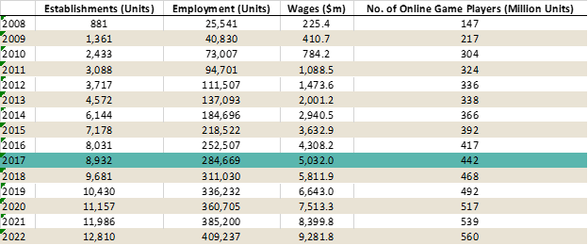
Key Statistics for the Industry (IBIS World)
If we look at number of establishments, we can see that the trend is relatively linear and increasing with no signs of slowing. This can only help the industry as their are many companies that exist and contribute to this growing sector. Employment has first risen, in 2008 - 2010 it rose exponentially and then tapered out to a more linear trend and with this, wages also moved accordingly.
Company Overview

Intro to Tencent
Tencent Holdings Limited is a Chinese investment holding conglomerate whose mission is: “ to enhance the quality of human life through Internet services”, which they accomplish through their various subsidiaries. These subsidiaries provide various Internet-related services/products and telecommunication services and technology both in China and globally. Tencent is the world's biggest investment corporation as well as one of the largest Internet and technology companies. Tencent is also well known as the largest gaming and entertainment company in the world. Their profits in gaming alone surpass all of the competition by a large margin According to Newzoo, Tencent’s revenue for the year ending in September 2017 game to a total of 12701 (In USD Millions). Compared to its next closest competitor, Sony, at a total of 6642 (In USD Millions). Its many services include social network, music, web portals, e-commerce, mobile games, internet services, payment systems, smartphones, and multiplayer online games, which are all among the world's biggest and most successful in their respective categories. (GBTimes Beijing).
Tencent controls hundreds of subsidiaries and associates in numerous industries, creating an extensive portfolio of ownerships’ and investments across a large range of businesses. Most of the investments fall within the technology sector, with the largest being the QQ.com and WeChat. It is one of the most active investment corporations in the world, with a recent focus on start-ups within Asia’s burgeoning tech scene, as well as abroad (e.i. see investment into the Finnish Company Supercell). The company employs more than 7000 employees, 60 percent of which is leading technical positions throughout the firm, accounting for roughly 23 percent of its total workforce. (sina)

Workings of Tencent
Tencent has the honor of becoming the first-ever China tech company ever to be valued at more than $500 billion, and in doing so, surpassed Facebook's valuation as well, with the market cap of Facebook being 477.96 billion USD while Tencent is 4.17 Trillion HKD. While gaming makes up a large part of Tencent's revenue, those of us in the U.S. may be most familiar with the company's WeChat mobile messaging chat platform, and recently (as of 2018), the game Arena of Valor. Tencent has also recently announced a suite of advertising solutions and resources that now enable U.S. marketers to directly engage Chinese consumers on Tencent platforms both in China and while they travel abroad, including WeChat. (Coleman, 2017) These new offerings provide U.S. brands and agencies with new ways to drive brand preference. This along with the creation of a dedicated U.S.based support team, will also assist Chinese consumers (particularly Millennials), creating yet another revenue stream for the tech behemoth. As stated by Poshu Yeung, Vice President of International Business at Tencent, on new developments. “ currently I am working closely with different U.S. marketers to understand their needs in China market opportunities and to share our experience in China together with our on-ground U.S. sales team. It is an exciting experience to us to help U.S. marketers to serve their exact needs and educate them how to maximize their marketing effort to better drive overall cost effectiveness and campaign ROI.”
Success inside China's Behemoth tech company often times will require a bit of cannibalisation within the company. As covered later in the section, Tencent will often have various internal brands compete against each other to see which is the better product. In example, Tencent most popular app, WeChat, came to fruition after founder Ma Huateng encouraged employees to compete against each other to create a mobile messaging business. That blockbuster along with others like Tencent QQ, helped propel Tencent's growth into the biggest publicly traded company in China with a market value of HK$4.17 trillion (as of April 2018) "We have a start-up mentality," says Ross Liang, a general manager at Tencent’s social network group. "At Tencent, there isn't a real clear line about who can't do what."
The competitive culture is drilled early on into their employees. This workforce is regularly told to look out for new products emerging in the industry, or emerging gaps in the markets. Failure to spot those trends and gaps can result in being outwitted by colleagues or worse competitors, which is considered "a shameful thing," said Alex Bai, a former product director now working for Baidu. New ideas often come from the bottom up, and employees proposing them can be rewarded with cash prizes. These prizes can range from 500 yuan for redesigning an interface to 1 million yuan for more significant innovations. Bai once received 300,000 yuan for improving the company's advertising business. (Washington Post, 2017)

Financials
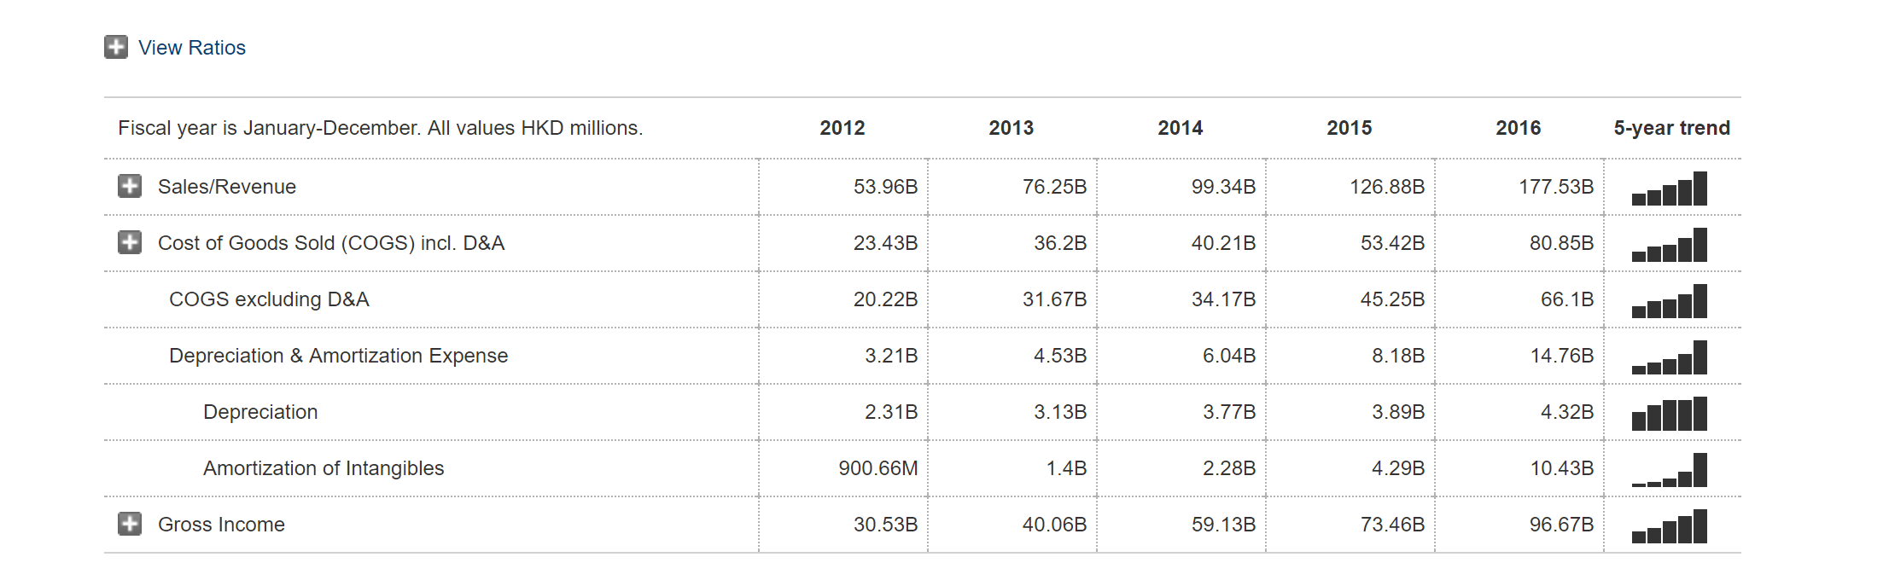
As of November 2017, the company has a market cap of US$534 billion (HK$4.17 trillion), and is China’s most valuable publicly traded company. Tencent has continued to grow its revenue streams, user base, and investments into new areas. It maintained an exceedingly high buy rating of 98% from stock watchers, credited to its bullish outlook. On 20 November 2017, it became the first Asian company to cross the US$500 billion valuation mark, and has also surpassed Facebook to become the world's most valuable social media company, while joining the ranks of the top 5 biggest firms in the world alongside Apple, Alphabet, Microsoft and Amazon. Tencent has been credited as one of the world's most innovative companies by numerous media and firms, such as Boston Consulting Group. Tencents incoming revenue has propelled its finances to be the number one publisher as far as ranked by revenue according to Newzoo. The next closet publisher as far as revenue is considered, is Sony, with their revenue being half of what Tencents Finalicals are. Currently Zachs’s Rank analysis gives the shares of Tencent as “Hold” value as their Earnings per Share (EPS) has been relatively volite for the last year. This is mostly because of Tencents current spendings and acquisitions and is not expected to negatively affect them long term

Marketwatch Financials for Tencent Holdings

The sales for Tencent, when focused on their games sector is divided into two main segments: PC and Mobile. These are the main focus of games in China, as Consoles never fully caught on in China, although they do exist, it is more rare when compared to PC or Mobile.

PC Games
For core PC games, Tencent reached approximately 14.6 billion in revenue. This revenue attributes 27% of their year-on-year revenue growth. This can be attributed to key titles including Dungeon Fighter Online and League of Legend. The focus for PC has been geared toward retaining core users and enhancing engagement for the players. The goal with this is to keep player in the ecosystem of the game and keep them coming back through various spendings within the game. This has been done through initiatives such as the League of Legends World Championship 2017 event held in China and a Dungeon Fighter - themed cartoon series. Tencent has also launched anniversary and seasonal content updates which were well-received by gamers and keep these game ecosystems fresh and un-stale.

Mobile Games
Mobile games grew by 84% year-on-year to which generated approximately 18.2 billion in revenue for Tencent as stated in Tencent’s 2017 third quarter earnings report shows revenue growth in smartphone games was contributed by existing and newly launched game titles such as Honour of Kings (also known as: Arena of Valor) in the MOBA genre, the China version of Contra Return in the Action genre, and Legacy TLBB Mobile, Legend of XuanYuan Mobile and Journey to the Fairyland Mobile in the RPG genre. On top of the previously mentioned games, the launch of Kings of Chaos also contributed to revenue growth and expanded our leadership into the strategy mobile game genre. In November 2017, Tencent started the pre-registration process for a licensed survival shooter game, Glorious Mission, and CrossFire Mobile’s update. Both received overwhelming registration responses. Tencent’s big winner out of all the mobile games listed though has been Honor of Kings. Honor of Kings currently has above 200 million players in China alone. The success of this game has big massive for the publishing giant and the growth of the game has been massive for the mobile market. So massive in fact that tencent has stated that they announced that Honor of Kings will get its own TV series based around the game. As stated from Tencent, the plot synopsis is as follows: “The live-action series will follow a Chinese teenage who plays Honor of Kings, as he battles his way to becoming a professional HoK player. The teenager will face challenges as he tries to follow the footsteps of his brother, whose career was cut short.” This is another way to keep players engaged and keep them within the Honor of Kings ecosystem (Hollingsworth 2018).
Corporate Structure

Past Successes
Tencent generated almost $13 billion of revenue from games in the first three quarters of 2017, far more than its global peers, almost by double the amount. As an example Sony made only around half as much. The publishing giant’s biggest advantage? Its pre-eminent position in China, where it controls around half the video games market. Fifty million people play its mobile game “Honor of Kings” every day, and has hit a user base that eclipses 200 million players in China Alone. The basic ingredient in Tencent’s success is its ownership of China’s most popular social networks, WeChat and QQ, which each have almost 1 billion monthly active users (Wong 2017). Tencent uses these networks to push its wares to users, and in turn, the $480 billion company’s games get the most marketing capabilities versus any of their competition.
Tencent, in addition to their usual markets, also try to cater to a small group of players, nicknamed “whales”, who spend money buying extra items for games, like upgrading the abilities of their characters. Their financial input is enormous as less than 10% of players contribute all the profits of typical mobile games in China, Deutsche Bank estimates. This is similar to the rule in marketing known as the 80-20 rule where 80% of your procedes come from 20% of your customers. This rule is extremely important in the gaming industry as without it, microtransactions would not be successful.
The Chinese government’s laws regarding foreign companies distributing their products in China, require foreign companies/games require a local publisher to distribute the game in China. This act only helps domestic companies, such as Tencent or Netease, further excel in China. Under Chinese regulations, Tencent is often a top choice to partner with, given its scale and distribution power. For example, Tencent publishes Activision Blizzard’s immensely popular “Candy Crush Saga” in China. One unique aspect of this process is that most games are not directly imported to China without changes. For example, instead of of China receiving the newest Call of Duty game every year as most of the western gamers do, Activision partnered with Tencent to release Call of Duty Online, an ever updating single game that doesn't require additional purchases every year. This can be used both ways however as most notably (and recently) Player Unknown’s Battlegrounds is the biggest game currently played by core PC users in China, and while Tencent is the publisher, the game had very little changes and worked almost in its entirety for Chinese gamers.
Because of Tencent’s worth, they often have the capital to purchase the competitors if they can’t create a game to rival it themselves. Even if smaller rivals emerge with new popular games, Tencent will often buy them up. If the domestic games being made are deemed subpar, Tencent looks abroad. In 2016, Tencent spent $8.6 billion on an 84% stake in Finnish game developer Supercell, whose “Clash of Clans” game has been among the top 10 Android games in China every month this year as of September, according to research firm Newzoo. Another aspect of this is Tencent has the largest stake in Riot Games by owning 93% of the company. Riot Games is most famous for being the development team behind one of the biggest games in the world, League of Legends. Despite owning majority stake in the development, Tencent also went ahead and created Honor of Kings, which can directly compete with league of legends, even though they are on different platforms, with League of Legends being on PC and Honor of Kings being on Mobile. This is one trend that we see often in Tencent as they often have multiple teams compete internally at the risk of cannibalizing sales overall. They believe this competition will drive teams to create the overall best product.
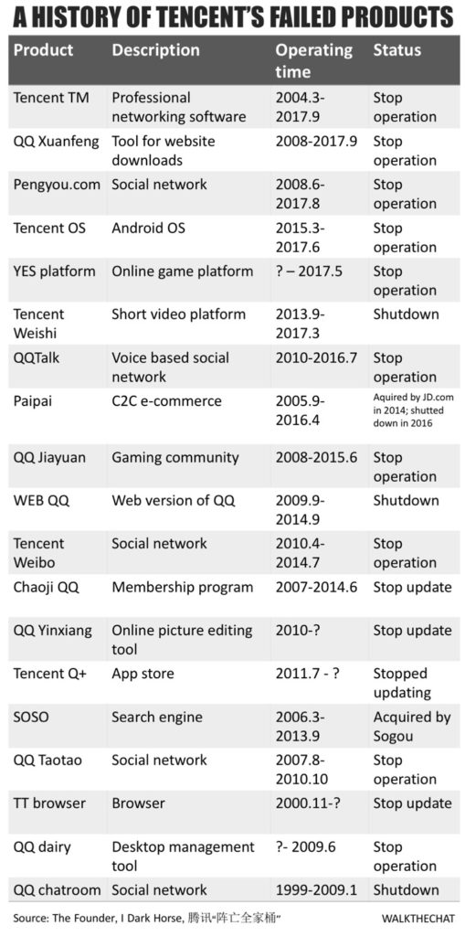
Past Failures
Tencent Failures (I Dark Horse)
As Tencent continues to grow as a company, it is important to look at the missteps along the way, and how to best learn from these mistakes. The abovelist is the failed products that tencent has had within the last two decades (2000-2017). The main ones covered will be Paipai, SOSO, and Pengyou.com. While Tencent has been largely successful in the game department, it has often faltered when it comes to exporting games out west, particularly because they have a China-First policy and the apps that they have exported (notably WeChat) have not done well due to poor localization. (Custer 2016). Because of this, Tencent does not often export there games to western audiences, and because they don’t often export games, there are no game failures from there end.
The first attempt was Paipai, a consumer to consumer (C2C) platform. In 2005 Tencent launched Paipai with the objective to test e-commerce. At the time QQ already reached 184.8 million monthly active users according to Tencent’s Q3 2015 earning report and was ranked among the top 500 websites globally by Alexa, a data analytics company. Tencent eventually realized Paipai didn’t stand any chance going against Alibaba. Instead, Tencent spent $214 million USD to acquire 15% of JD.com. As part of this strategic alliance, Paipai was grouped into JD.com and was eventually shut down in April 2016 for the reason of being “unable to control fake products”.
Second attempted success by Tencent is SOSO, a search engine website. According to Nielsen, a market research company, SOSO’s market share surpassed Google in mainland China in 2009. The rest of search engine market depended heavily on web browser’s built-in search feature. Tencent was not able to capture the web browser market, and as a result, SOSO got little traffic. Tencent ended up owning 44% of Sogou, a competing search engine, when it went for its $585 million IPO in November 2017. Even though Baidu still dominate the search market, the size of the desktop search queries is diminishing as users are shifting to mobile, opening a new opportunity for Sogou and Tencent.
The last failed aspect of Tencent that will be discussed is Pengyou.com, which is a social network based on user’s friend connected from QQ. It reached 248 million MAU in Q2 2012, at the time Qzone had 589 million MAU.As a business strategy, Tencent often has multiple internal brands that compete against each other, WeChat was also one of the projects that won the internal competition and raised to the top. In this case, Pengyou lost the competition to its internal counterpart Qzone.
By investing in various industries, Tencent is gaining knowledge and is eventually acquiring part of its competitor. These failed products turn out to be experiments that give Tencent a good understanding of markets before its investments. Within this investment process, Tencent fully understands the industry they are breaking into and understands how to best proceed. We can observe a similar trend than in the e-commerce market: Tencent is switching from an “in-house development” strategy to an “invest & acquire” strategy.

SWOT Analysis
STRENGTHS  1. Excellent R&D facility, more than 50% employees focus on it  2. It has well diversified business portfolio, which provide various service on internet to attract customer base  3. It has strong position in instant marketing domain, it has got a lot of patents under its name  4. Leaders in internet services in China | WEAKNESSES  1. It has sole presence in China which makes it vulnerable to risk, if any associated with the country  2. Unable to reach globally, and use huge global internet service Market
OPPORTUNITIES  1. There growing internet usage in the country in various fields  2. Strategic business expansion by coming up with new services and patents  3. Western expansion of goods and services | THREATS  1. Increasing competition due to global player  2. Strict government laws and policies

Strengths
The first major strength that Tencent has working for it: its massive research and development facilities. These facilities account for 50% of Employees at Tencent which accounts for 22398 employees as of 2017. R&D facilities are the backbone of Tencent as they thrive on innovation and putting the best product out there, as stated before, often at the expense of cannibalism of sales. The next major strength is the diversified portfolio of Tencent. This company is one of the largest entities in the world and would be the western equivalent of Amazon partnering with Facebook in terms of size. This allows Tencent to fully dive out and make the best product in any situation. With this large diversification, tencent also holds many patents in its name. According to Technode.com, wrote as of 2017, “Tencent’s patents reached 6,285, far more than Baidu’s 903, and Alibaba’s 2,052.” (Yoo 2017) This keeps Tencent in the top percentile of these tech giants as the parents guarantee the law will side with them in terms of copying a product. Lastly, They are one of the leading internet services in China, and have close relations with the Chinese Government. This leads the government to be more lenient on the company being a digital monopoly.
Weaknesses
One large weakness in Tencent is that it is primarily a China oriented country. The problem with this is that any negative association with the country, will also reflect on Tencent as a whole. Any risk with the country is a risk for Tencent. This can leave many potential vulnerabilities in how they operate moving forward. The other large weakness is that while they have the capital to become a global company, they are not. Because of this they lose a large market in the global community. While they have always promoted well in China, they are not the global enterprises that there competitors are slowly becoming.
Opportunities
As the economy progresses forward, internet usage in the country increases. The number of internet users in China from December 2006 to December 2017 has increased from 137 million to 772 million people (Statista 2017). This growth leaves a lot of unexplored markets as the internet becomes more widespread, there may be opportunities in new markets that didn’t exist digitally. With this new possible markets, this leads Tencent’s R&D department to create new patents and for upper management to expand business into sectors that are previously unexplored because of lack of internet, or new technologies being created (i.e. the Blockchain system). Lastly, because Tencent has been so focused within China, there is a huge opportunity for a global expansion. As stated before they have the capital to do so, and we should expect a global push within the next decade according to Boston Consulting Group.
Threats
One of the greatest opportunities can also be its greatest weakness. Global expansion, if done right, can lead to a huge increase in profits and revenue and will see its EPS go up, however, if done poorly can ruin the companies image, both in China and abroad. Moving forward it is important to know any cultural differences in both games and apps when it comes to localizing for foreign markets. In example, in 2006 Home Depot saw the rising Chinese economy and decided it was a good time to move into the market. after they had opened 12 stores within China, they realized the DIY hobby does not exist in China as the Chinese saw DIY as a sign of poverty. By 2012 Home Depot shuttered its stores and took a $160 million hit to its bottom line. This is the threat when it comes to globalizing a company without prior knowledge of the culture. The other, and most prominent threat is the government's rules and restrictions. As stated earlier, the Chinese Government is close to Tencent, this however does not make them exempt from the law. This could be bad as the government has the potential for banning a popular game for various reasons that could affect Tencents bottom line negatively. In recent news of this threat, the Government has recently put a restriction on the amount of time that children can play games for. “Analysts warned the limitations on play time will have a negative impact on Tencent, one of Asia’s biggest public companies, which pulls in about 30% of its revenues from mobile gaming.”( Abkowitz 2017) This will particularly affect free to play games the most where a large chunk of revenue comes from players under the age of 18, said China Merchants Securities analyst Richard Ko. Players can now play up to certain levels for free, but then must pay to continue to more advanced levels, due to the time restrictions currently in place for children. Mr. Ko estimates the limitations will lower Honor of Kings revenues by 5% for the year, impacting Tencent’s overall mobile gaming top line by 1.6% (Abkowitz 2017).

Gaming Trends in China
When looking at China’s game trends, the first aspect noticed is the game aesthetic, or the art style. The Chinese art style is usually traditional and has tie-ins with mythology of the area. Differences from western games can range from color usage, proportion of characters, hair and dressing style, face shapes, accessories, etc. Although these factors may not be the most crucial ones considering the entire game development process, they will become major disadvantages when the game entering another market if they are not properly dealt with. Because MMORPG is the most popular genre of game in China, the User Interface (UI) is often cluttered and gives the player an abundance of information. This appears to be what players desire when playing these games. The setting of these games can also make a difference as In China, games with background story about the Three Kingdoms or Journey to the West can be very popular. However, western players have a harder time relating.
Core mechanics of the game are also important to understand each market. One trend to understand is the game pacing. Given the same amount of time, Chinese gamers consume content much quicker than western gamers by this I do not mean they play games quicker, but consume more information in that time. This could be from a variety of reasons and how the games are played but the data shows that Western gamers are slower when it comes to the information consumed within the game. (Lu, 2017). For monetization methods, Martin Lu, the general manager as Seasun Inc. (the publisher under the parent company kingsoft) stated: “Free-to-play monetization model started in Asia and is very well operated in China, and Chinese gamers get used to it. Pay-to-win is something very common in China which people generally accept, despite the fact that it’s not recommended: pay-to-win is not the best monetization approach even in China. Compared to western players, who prefer to pay to unlock levels or content, gamers in China tend to pay their way out including defeating the boss, skipping a hard level, etc.” The way pay to win works in China is different to that of the west. This has tied in to the increased consumption of content that the Chinese gamer prefers. Since they want to experience more in the same time frame, they will often pay to skip a difficult section in order to get more content out of it. The easiest way to look at it is often a sensory intake, where alot of western games prefer a clean and simple user interface, the average Chinese gamer prefers a little more cluttered, given that the clutter is still giving the user relevant information about the game.
Marketing cost has soared in recent years. In general, mobile games maintain their user base via continuous user acquisition activities. This is familiar for western games as well as games as a service increases in popularity. In average, the marketing cost including user acquisition operations goes as high as 60% (Chinese Game Industry Report) of the entire marketing budget. So, the increasing marketing cost affected their bottom line drastically. Lastly one of the other large trends in China is esports, which will be covered later below.

Bringing Games to the West
For aesthetic purposes, bringing a game to the west should include reskinning for western audiences. This does not only apply to in game characters but also User Interface. In China, it is popular to have a cluttered UI which give the user a lot of information at once. One way this issue can be resolved is by changing the length of text between different languages while working on UI localization. For the game setting, when localizing a game for western audiences, it is important to set it during a period that the audience would understand and relate to. As mentioned above, the game pace in China is quicker than most western gamers are used to, in turn, when localizing a game, it is important to slow down the mechanics of the game.
Another instance to look at is game genre. Genre is important to know when localizing a game for the west, where a pay to win model may be prevalent in RPG’s in China, it would not work for western markets. With this you also must know what games are popular to what audiences. Speaking in global terms, Playerunknown's Battlegrounds (PUBG) and Fortnite are the two biggest games in the world as of April 2018 (Newzoo Core PC Rankings). Both are battle royale style games that put 100 players in a single map and have them fight until only one remains. This style game has a global audience for it, but if we take another game, the Dynasty Warriors Series, we see that while it has a niche following in Western Markets, it caters more toward Asian markets. This distinction must be made when localizing games for western audiences.
The last crucial distinction that should be made is overall playstyle of games. While genre does dictate what game is played, given the same mechanics a player may play the same game vastly different, given their locations. This is also what can be known as a games “Meta” and it is vital to understand all aspects of the game play. This mainly applies for competitive games, however can still apply to single player and MMO’s. To use PUBG as an example again, the strategies used by Chinese gamers differs from those used by European gamers. This can often be seen as the meta shifts how the top players from each region are performing. The flexibility in this meta well help the localization of any games as it is a way to make it the players own experience.

eSports
Esports started off as a grassroots movement. It was just a bunch of gamers, fighting for glory and small monetary prizes. Since these early days, the popularity of eSports has exponentially expanded. It has undeniable been growing. The reported number of eSports viewership is expected to be around 589 Million viewers, with about half of that coming from Asia. this also increased revenue by 35% leading to a 1504 million (USD) in expected revenue. In the Asia region, the League of Legends finals drew the biggest crowd at 49.5 million viewers. This generated 173000 attendees and $5.5M in ticket revenue.
Mobile esports is more popular in the East than in the West, especially in China and has been accelerated by the mobile-first culture of the region. In Asia, mobile esports is expected to follow a similar structure to that of PC, with the top mobile games being played and large stadium events taking place with large viewership. Casual mobile games hold a strong position in the esports scene in Asia, which differs from the West where competitive genres dominate the market. Giant Network’s Battle of Balls Professional League was the world’s first casual mobile esports league and its 2017 Global Final will be the first mobile esports event held in Mercedes-Benz Arena Shanghai. About 13,500 people paid 100 yuan-180 yuan each to watch teams play "Honor of Kings," a Tencent game that just ahead of the finals came under criticism from the official People's Daily newspaper as an addictive "poison" for the minds of youth. While both competitive and casual games exist, there appears to be a rising trend of casual esport games rising as they are easier to understand from the viewers standpoint. The tournament barely broke even, despite drawing millions of online viewers. "At the moment, we treat esports as a marketing tool to promote the games and engage gamers," said Stella Lui, Tencent's investor relations director. "I would say esports will [eventually] develop like FIFA or the NBA." This should be taken advantage of as the ‘early adopters’ of eSports will me the most profitable in the long-run.
One large aspect in any esports game is the topic of viewership. While some game are great to play competitively, they are not designed to be viewed in such as matter. Games such as League of Legends and Dota 2 have a natural top down viewing so you can see what is happening to all players at all times. on top of this the map is symmetrical much like in Basketball or Football. The complication then stems from maps that are not symmetrical, and games that have a different camera angle. As T.L. Taylor puts it “The networked nature of the games, and the fact that the playing field is often distributed over multiple devices … has produced a complex formulation of spectatorship”. T. L. Taylor is a sociologist and professor currently working at MIT. She specialises in researching the culture of gaming and online communities, in particular, eSports, live-streaming, and MMOs. She later states that a lot of these issues still stem from the grassroot origins of esports, as their is a lack of attention to any outsider that wants to view it casually. As of now (Early 2018) most eSports in western cultures are not used to having any mainstream attention, and therefore, do not cater to the casual audience. This process is one big difference when compared to Asia most notbaly South Korea, but in China as well. Many publishers have a lot of things they can do based around eSports. In example, at the end of 2017, Activision Blizzard announced the Overwatch League. This would distribute eSports teams to geographical locations, much like real sports teams. This kind of action had not been done before and has huge marketing and branding implications. While the numbers are not specifically given, the amount of possible fans for China’s team, The Shanghai Dragons, has a huge marketing potential, and so far the owners of these teams (Such as Robert Kraft who owns the New England Patriots) has stated that revenue from the teams has double expectations. As of May 2017, Tencent announced that the The Chinese League of Legends Pro League will become the first to adopt a franchise model, and even more recently, announced that there will be franchises available for Honor of kings in the future, this news was just realised as of March 2018. This move could bode well for the esport’s long-lasting profitability. The franchise model will be city based and be most comparable to the Overwatch League as mentioned above (Ashton 2017).
The potential for success on esports teams is massive. As of 2018 there are 72 million esports enthusiasts in China alone (Newzoo) an enthusiast counts as any person who consumes more than 4 hours of content a week. This number is only expected to rise, with no signs of slowing down. With this potential there is a new side to games and microtransactions that never have been considered by companies. An example of this is can be seen on the popular live streaming app Twitch.tv which is owned by Amazon. During the livestream of various esports titles, there is a live chat, to virtually text others also watching the same stream. Those that pay additional money to support a specific team are able to get various E-motes based around the team, whether it be the logo of the team to show support, or one of the players faces captured to look comical. This is a unique revenue stream that had not existed before eSports. That is why it is crucial to not just disregard it as it was during its grassroot movement.

Competitor Analysis

Increased Revenue
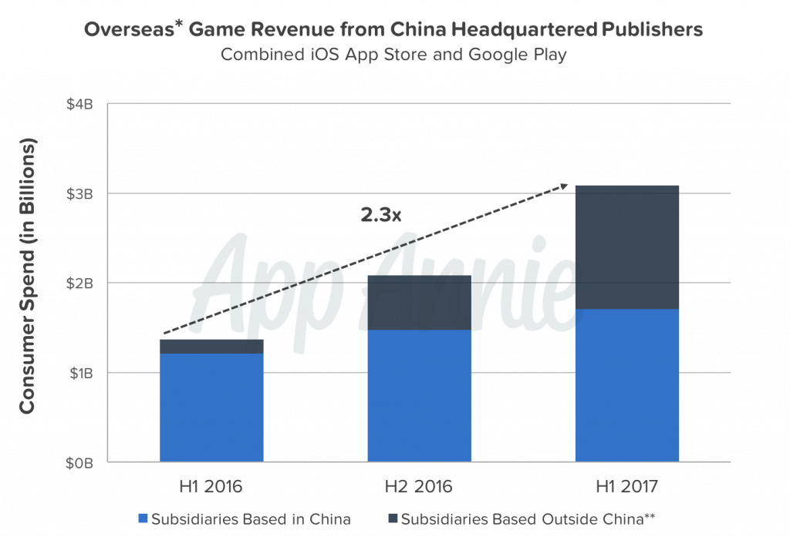
Over the course of the last couple of years western expansion has become much more of a viable option for Chinese companies to expand their games into the Western Markets. Revenue has more than doubled over the past 3 years, and seeing that it is a linear trend, we can expect it to grow at a similar rate. This leaves open a large market to deal with and would be a missed opportunity of untapped. (Kristianto, 2012) Looking at the Newzoo rankings of countries by game revenue, it can be seen that bringing a game west can give an additional $82,838 million (Based on the top 10 countries by revenue, excluding China, South Korea, and Japan) This revenue eclipses China’s revenue of $52,536 million and is a great addition for any company, if done right. The graph excludes Chinese subsidiaries based in different countries

Game Revenues from China (AppAnnie)

Successful Western Expansion
Most Chinese companies that have expanded overseas has only done so by licensing. Tencent has large investments in both Epic Games and Activision Blizzard (at 40% and 25% respectively) as well as owning a majority of Riot Games, who’s popular game “League of Legends” is the arguably the biggest game in the world. Tencent however doesn’t push its in-house developed games to western markets. In fact, most Chinese Publishers won’t publish games made for China in western markets. Any company that has oversea expansion (Such as NetEase and Perfect World) do so out of subsidiaries based in the US, and while they make games specifically for the US, it is not coming from the headquarters based in China. There are a few exception to this, where most of the big Chinese publishers make their games for China only, there are a couple of small ones that surpass this.
As mentioned in the above section, one of China’s game's biggest draws is using its heritage and mythology to relate to their target markets. This may not work in Western Markets. When these style games enter this market, If they want to remain true to their heritage, it will most likely have to be romanticized. If not, they will have to fundamentally change the product, be it aesthetically, or the core of the game. This was stated in AppAnnies review of Chinese Publishers reaching a global market: ” China headquartered publishers that are successful in outside markets tend to design games with visual styles and themes that have a wider appeal internationally, taking references from popular culture such as movies and television.” (Kristainato, 2017) In the case of Honor of Kings, Tencent has changed the look to the game of western markets and even has partnered with DC Comics in order to put DC characters in the game, such as Batman (Courtesy of the Arena of Valor Website). This brand differentiation is crucial for the game to succeed, and bringing well known characters from established franchises into the mix will only help the game further succeed.

Honor of Kings’ Biggest Hurdle: Vainglory
Vainglory is arguably Honor of King’s biggest competition, being that they are both in the same genre as well as both with a mobile focus. Vainglory is a video game developed and published by Super Evil Megacorp for iOS and Android devices. The game is a simplified version of the PC-based MOBA genre where two opposing teams of three players fight to destroy the enemy base by controlling the path between the bases, which is lined by turrets and guarded by AI controlled enemy creatures. Off the path, players battle for control points that provide resources. Vainglory also has a large Esports Following, boasting a league of 16 teams competing for a grand prize of $120,000 USD for the 2016 Season. The game is widely regarded as the best MOBA on mobile with a Metacritic score of 84, the highest of the genre for mobile.
Vainglory isn’t without its faults however and Honor of Kings can be set to capitalize on it. As Trevor Owens, The owner of A Medium Corporation and Author, stated “Vainglory has been misallocating resources and making their product better and better with diminishing returns.” Every dollar a business spends on improving its product is a dollar it could have spent on marketing and advertising, or the growth of the product. Vainglory adding a 5v5 mode to compete with Honor of Kings will only help satisfy current customers, it won’t attract new ones. Every business will receive diminishing returns from trying to make more customers happy. This will leave open a window for competitors to enter the market.
Honor of Kings/Arena of Valor SWOT Analysis When compared to the competition

STRENGTHS  Huge Distribution Channel through Tencent  Gamers in China can’t download competition  Popular Game Genre (MOBA’s are popular everywhere) | WEAKNESSES  Graphics Not good  Controls not good  Pacing of game is not right
OPPORTUNITIES  First Move by company may most likely come out on top  Advertise Game for western markets, (Most casual gamers don’t know about competition) | THREATS  Competition has a better game in most aspects  When compared to competition, Honor of Kings falls flat.

Strengths
One of the biggest strengths of Honor of Kings is its massive distribution channel through its publisher, Tencent. Because of Tencent’s capital, they have the budget for marketing that can rival any company. This can be one of their biggest assets as the competition, being Vain Glory, has no where near the capital that Tencent has. Another strength, at least while in China, is simply that Vain Glory is not available in the region. Honor of Kings is the only game of its style available on mobile. Lastly is a strength of the genre. MOBA style games are popular worldwide and have a mass appeal because of that. These games all have similar styles and are easy to understand the core concepts. This gameplay style can transcend any language barrier, at least at a basic level of play.
Weaknesses
Despite its popularity, Honor of Kings is not without its weaknesses. If you were to boot up the game currently on a mobile device it will look good and you may be impressed on the visuals, however, when compared to Vain Glory’s visuals, you can see that it is outclassed. The gameplay visuals in Honor of Kings are only par per other mobile games. While this can lead to more gamers playing on devices that may not be able to handle a better looking game, it can also lead to a lack of retention from the current player base. On top of the graphics, the controls do not feel intuitive as compared to the competition. In all MOBA style games, you always move your avatar by clicking on the location where you want the character to go. However, in Honor of Kings, you use a joystick to move the character. Not only does it feel odd and unintuitive, but it also hinders the games pacing, which already feels sporadic and is either too fast or too slow at certain points.
Opportunities
With opportunities, it is important to remember that the early bird gets the worm, This is the case with these two mobile MOBA games as well. Since both have a low but dedicated western audience, The first company to make a large scale move into advertising will most likely come out on top. The key to success in this case is advertisement, and when backed by Tencent, we can assume the budget for advertisement is large. Overall Tencent made $1.5 Billion USD for revenue in advertisement alone in 2017 Q2 (Tencent Quarterly Report Q2 2017). For the case of Honor of Kings/Arena of Valor versus Vainglory, the first company to successfully market the game to a large audience will be key. This is apparent in how the mobile game market works, especially if you look at past competitive mobile titles.
Threats
The biggest threat to Honor of kings as a game, is the opposition is better. It is better reviewed and more praised for its controls and gameplay (Metacritic average scores). Now while personal tastes of each game may very, Honor of Kings appears to me a much more casual MOBA, whereas Vainglory is much more competitive. There is much more depth to Vainglory then there is Honor of Kings, however, this may work in Honor of Kings favor, is the casual game can appeal to a larger audience.

Conclusion

When looking at the industry, we can see a couple of large scale trends. For one a large indicator is growth. The video game industry as well as the esports industry are both growing steadily and are expected to hit all time industry highs by 2020, both in overall revenue and employee numbers. When comparing the competitors in the industry, We can see none quite have as large of a market share as Tencent has managed to form for itself, leading in the publisher dominating the Chinese markets. The question then comes if Tencent can continue this market share outside of China with their hit game Honor of Kings, rebranding to Arena of Valor for the west.
If Honor of Kings is in the right hands, the game will succeed and be a huge hit. Fortunately it is being published by Tencent, the biggest Game Publisher in the world. If you look at their track record, you will not only see a huge array of successes, but the failures that tencent has had, when they do have them, are usually do to cannibalism of sales. In this case, even when a product of Tencent fails, they still get profit.

Bibliography

(n.d.). Retrieved from https://www.google.com/search?q=HKG:0700&tbm=fin#scso=uid_9AjwWp_jDOqd0gKSzpTABg_5:0&wptab=COMPANY
Ashton, G. (2017, July 13). Franchising Comes to Chinese League of Legends. Retrieved from https://esportsobserver.com/franchising-comes-chinese-league-legends-ending-relegation-lpl/
Chen, T. (2018, January 09). Tencent's product failure history. Retrieved from https://walkthechat.com/tencents-product-failure-history/
CHINA MOBILE GAMES MARKET 2016. (2016). Nordic Games Institute. Retrieved from https://www.neogames.fi
Custer, C. (2016, May 25). 3 reasons WeChat failed internationally (and most other Chinese apps do too). Retrieved from https://www.techinasia.com/3-reasons-wechat-failed-internationally-chinese-apps
Event-driven, M. M. (2017, August 28). Tencent's 'Honor Of Kings' Will Cannibalize International Sales Of 'League Of Legends'. Retrieved from https://seekingalpha.com/article/4102304-tencents-honor-kings-will-cannibalize-international-sales-league-legends
Fitchnews Singapore. (2017, May 26). China's Tencent is the Most Active Corporate Investor in Asia's Tech Startups. Retrieved from http://fintechnews.sg/9657/fintech/chinas-tencent-active-corporate-investor-asias-tech-startups/
GBTime Bejiing. (2017, October 09). Tencent tops video game market in H1. Retrieved from https://gbtimes.com/tencent-remains-worlds-most-successful-video-gaming-company
Hollingsworth, D. (2018, April 26). Tencent to make scripted TV series focused on Honor of Kings esports. Retrieved from http://www.esportsinsider.com/2018/04/tencent-to-make-scripted-tv-series-focused-on-honor-of-kings-esports/
Huang, Z. (2017, July 28). China's smash-hit mobile game is going West without many of its Chinese elements. Retrieved from https://qz.com/1040706/tencents-smash-hit-mobile-game-honor-of-kings-is-coming-to-the-us-without-many-of-its-chinese-elements/
Kristianto, D. (2017, August 21). China Headquartered Game Publishers Level Up on the World Stage. Retrieved from https://www.appannie.com/en/insights/market-data/china-headquartered-game-publishers-level-world-stage/
Lanxon, N. (2017, June 01). China Just Became the Games Industry Capital of the World. Retrieved from https://www.bloomberg.com/news/articles/2017-06-01/china-just-became-the-games-industry-capital-of-the-world
Loizos, C. (2015, July 06). Chinese Companies Delisting from U.S. Indices? Maybe Not. Retrieved from https://techcrunch.com/2015/07/05/chinese-companies-delisting-from-u-s-indices-maybe-not/
Lu, M. (2016, September 13). Why Successful Games in China Rarely Obtain the Equivalent Success in the West. Retrieved from https://www.linkedin.com/pulse/why-successful-games-china-rarely-obtain-equivalent-mantin/
Lu, M. (2017, November 27). Trends of China Game Market and Strategies You May Consider (Report). Retrieved from https://www.gamasutra.com/blogs/MantinLu/20171127/310256/Trends_of_China_Game_Market_and_Strategies_You_May_Consider_Report.php
Myers, T. (2016, September 12). Who Are The Top Chinese App Publishers? Retrieved from http://www.businessofapps.com/who-are-the-top-chinese-app-publishers/
Online Games in China(Rep. No. 6221). (2018, February). Retrieved http://clients1.ibisworld.com/reports/cn/industry/default.aspx?entid=5016#
Owens, T. (2017, July 15). How Vainglory Can Compete with Honor of Kings – Esports and Gaming Analysis by Owens – Medium. Retrieved from https://medium.com/esports-and-gaming-analysis-by-owens/why-honor-of-kings-is-crushing-vainglory-2f728a38e53d
Statista. (2018, April). Tencent: Number of employees 2017 | Statistic. Retrieved from https://www.statista.com/statistics/223719/number-of-tencent-group-employees/
Statista. (2018, January). China: Number of internet users 2017 | Statistic. Retrieved from https://www.statista.com/statistics/265140/number-of-internet-users-in-china/
Takahashi, D. (2017, February 14). The U.S. game industry has 2,457 companies supporting 220,000 jobs. Retrieved from https://venturebeat.com/2017/02/14/the-u-s-game-industry-has-2457-companies-supporting-220000-jobs/
Taylor, T. (2012). Raising the stakes: E-sports and the professiobalization of computer gaming. Cambridge, MA: The MIT Press.
Tencent. (2017, November 15). TENCENT ANNOUNCES 2017 THIRD QUARTER RESULTS[Press release]. Retrieved from https://www.tencent.com/en-us/articles/15000651510741924.pdf
The Chinese Gamer | 2017. (2017, June 7). Retrieved from https://newzoo.com/insights/infographics/chinese-gamer-2017/
Vizard, S., Chahal, M., Millington, A., Bacon, J., Roderick, L., Woollen, P., . . . Joy, S. (2016, August 17). China's biggest brand on its plans to conquer the West. Retrieved from https://www.marketingweek.com/2016/08/04/chinas-biggest-brand-on-its-plans-to-conquer-the-west/
Wong, J. (2017, December 27). What Can Dislodge Tencent as King of the Videogames? Retrieved from https://www.wsj.com/articles/what-can-dislodge-tencent-as-king-of-the-video-games-1514370601
Yoo, E. (2017, July 12). Report shows Tencent is the king of patents · TechNode. Retrieved from https://technode.com/2017/07/12/report-shows-that-tencent-is-the-king-of-patents/
Zigu. (n.d.). Tencent Holdings SWOT Analysis | USP & Competitors | BrandGuide. Retrieved from https://www.mbaskool.com/brandguide/it-technology/4709-tencent-holdings.html
澎. (2017, October 14). 腾讯：公司党员超7000人，带头开发微信等代表性产品. Retrieved from https://tech.sina.cn/2017-10-14/detail-ifymvuys9864621.d.html

https://tech.sina.cn/2017-10-14/detail-ifymvuys9864621.d.html?
http://www.cgigc.com.cn/member/upload/pms/201708/03180814msz5.pdf

